Regulations for the Electronic Auction (ID. No. REAL 2026/23)
for the sale of locomotive spare parts

- General Provisions
  - These regulations (hereinafter – the Regulations) set out the procedure for organising an auction of locomotive spare parts by the limited liability company “LDZ CARGO”, registration No. 40003788421, with its registered office at 147 k-1 Dzirnavu Street, Riga, LV-1050 (hereinafter referred to as the ‘Seller’) are organised.
  - Method of sale: an electronic ascending-bid auction (hereinafter referred to as the ‘Auction’).
  - The Auction is organised on the electronic auction website http://auctioncargo.ldz.lv (hereinafter – EAW).
  - The Auction is organised by an auction commission established by the Seller (hereinafter referred to as the ‘Commission’).
  - The Auction will commence on 29 October 2026 at 13.00. The bidding period for the Auction shall end on 29 October 2026 at 14.00. The end of the bidding period for each subsequent lot shall be set at 10 (ten) minute intervals following the end of the previous lot.
  - The Seller shall not compensate Auction participants for any expenses and/or losses incurred by them in connection with their preparation for and participation in the Auction.
  - Personal data of natural persons contained in documents relating to the Auction will be processed in accordance with Regulation (EU) 2016/679 of the European Parliament and of the Council of 27 April 2016 on the protection of natural persons with regard to the processing of personal data and on the free movement of such data, repealing Directive 95/46/EC (General Data Protection Regulation), Article 6(1)(f), and the first paragraph of Article 25 of the Personal Data Processing Act.
  - The purchase contract with the successful bidder shall be concluded in accordance with the draft purchase contract attached as Annex 1 to the Regulations, in the manner provided for in the Regulations. The terms of the purchase contract may be mutually clarified prior to the signing of the contract, provided that such clarifications are minor and relate to the formalisation of the auction result.

- Information on the subject of the auction
  - The seller is selling second-hand locomotive spare parts (hereinafter referred to as ‘Spare Parts’) at auction.
  - Description of the Spare Parts:
TEP70 locomotive bogie frame  (SAP No. 16000032935)  Quantity: 2 items  Year of manufacture: 1989  Approximate unit weight: 3.60 tonnes;  Condition: In need of repair. No warranty. | 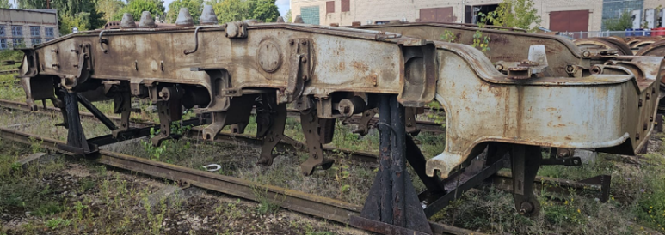
ЭД-121А У1 traction electric motor  (SAP No. 16000006603)  Quantity: 3 units  Year of manufacture: 1989, 1991, 1994  Approximate unit weight: 2.80 tonnes;  Condition: In need of repair. Complete set. No warranty. | 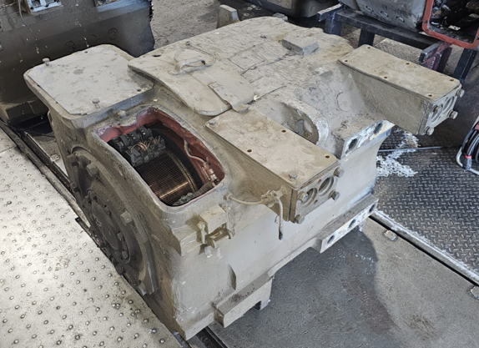
ЭД-121А У1 traction electric motor (disassembled)  (SAP No. 16000006603)  Quantity: 3 units  Year of manufacture: 1989, 1990, 1993  Approximate unit weight: 2.00 tonnes;  Condition: Stripped down. No copper. No warranty. | 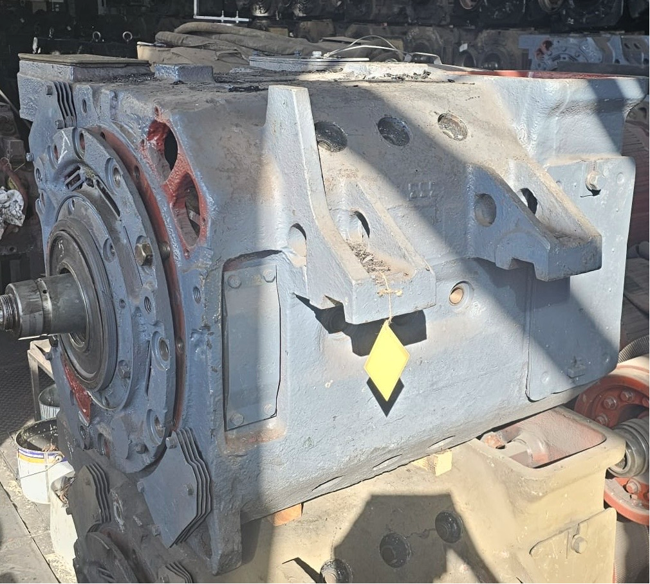  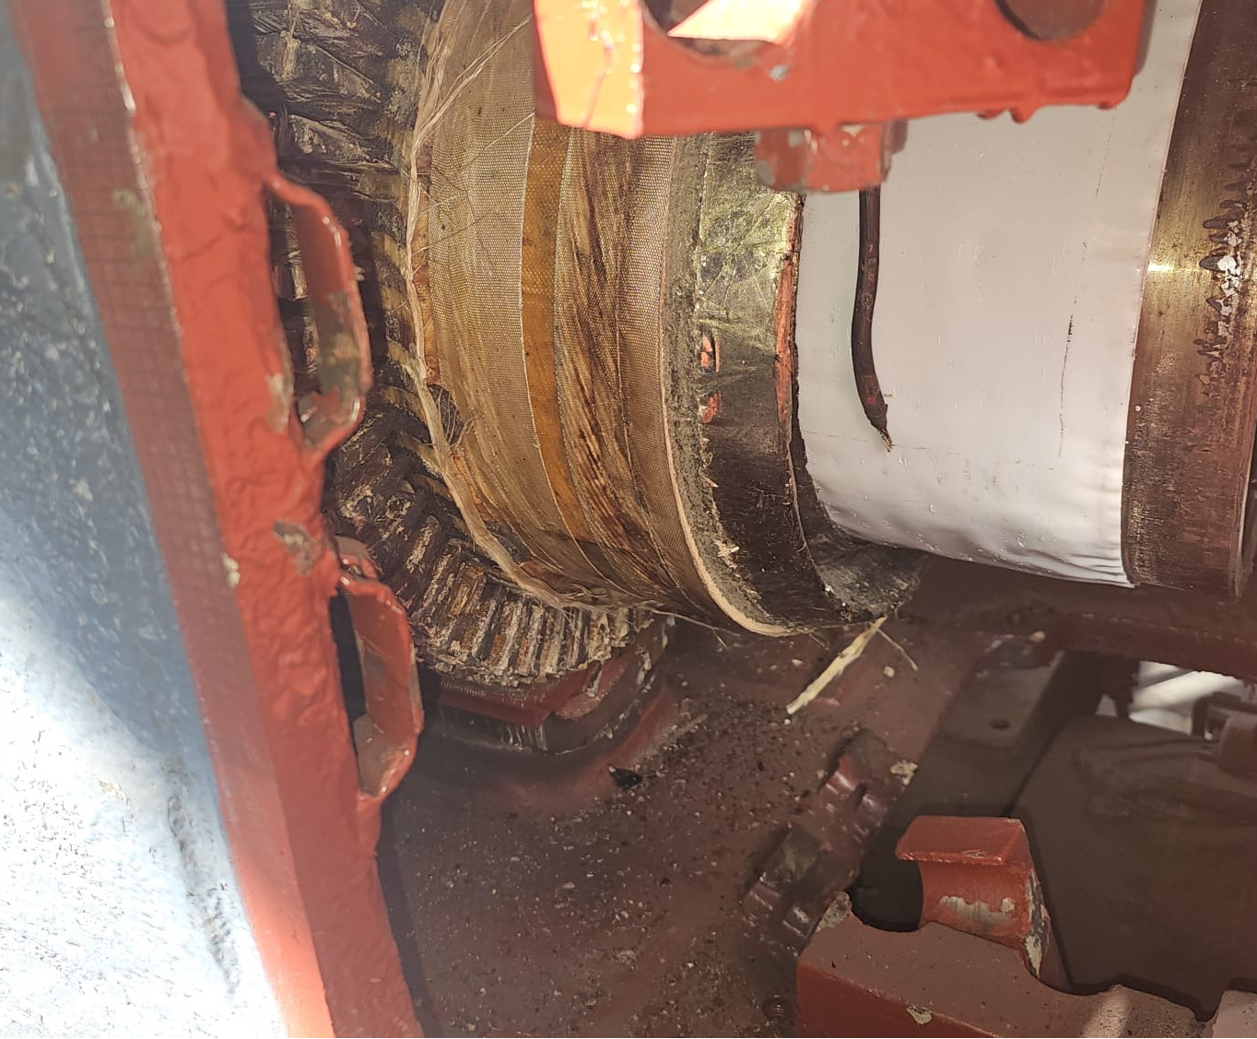
TEP70 locomotive wheel set  (SAP No. 16000007425)  Quantity: 15 items  Year of manufacture: 1989  Approximate unit weight: 2.40 tonnes;  Condition: In need of repair. Complete set. No warranty. | 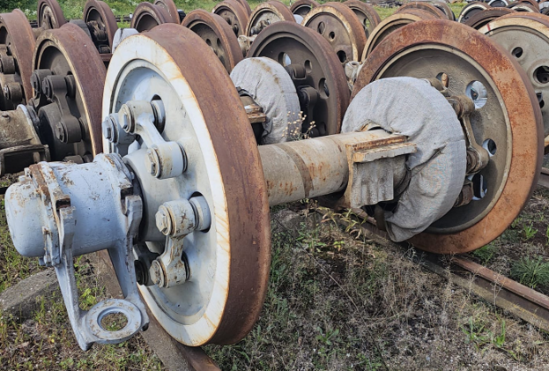
10Д100М diesel engine block  (SAP No. 6000025240)  Quantity: 1 unit  Year of manufacture: 1980  Approximate unit weight: 5.70 tonnes;  Condition: Block without accessories. No warranty. | 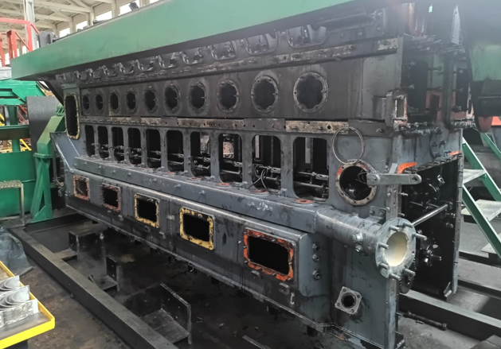
2А-9ДГ diesel generator set (SAP No. 16000006589)  Quantity: 1 unit  Year of manufacture: 1985  Approximate unit weight: 26.00 tonnes;  Condition: In need of repair. Complete set. No warranty. | 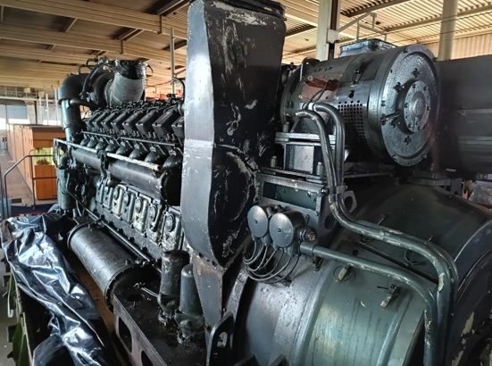
2А-5Д49 diesel engine block  (SAP No. 16000006589)  Quantity: 1 item.  Year of manufacture: 1985.  Approximate unit weight: 4.00 tonnes;  Condition: In need of repair. Complete set. No warranty. | 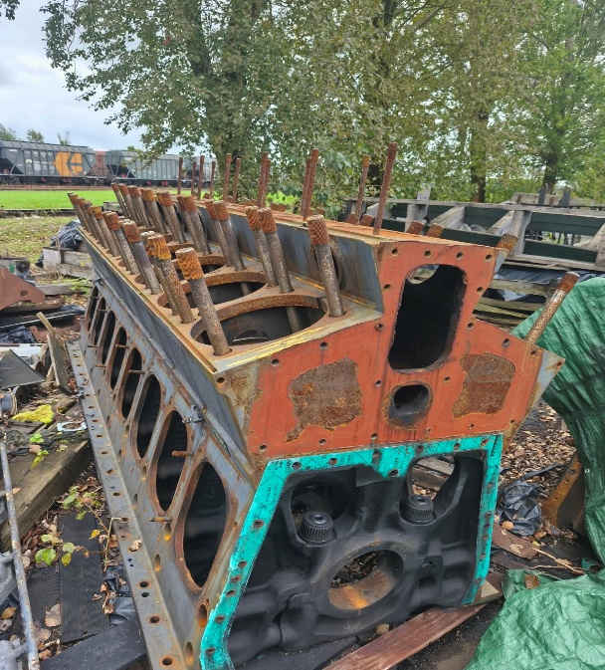
Upper crankshaft of the 10Д100 diesel engine  (SAP No. 16000007299)  Quantity: 2 pcs.  Year of manufacture: 1985  Approximate unit weight: 1.05 tonnes;  Condition: Requires grinding and repair. No warranty. | 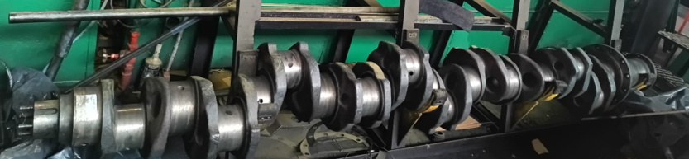
Lower half of the crankshaft for the 10Д100 diesel engine  (SAP No. 16000007300)  Quantity: 1 piece  Year of manufacture: 1985  Approximate unit weight: 1.07 tonnes;  Condition: Requires grinding and repair. Complete set (with anti-vibration mount and gear). No warranty | 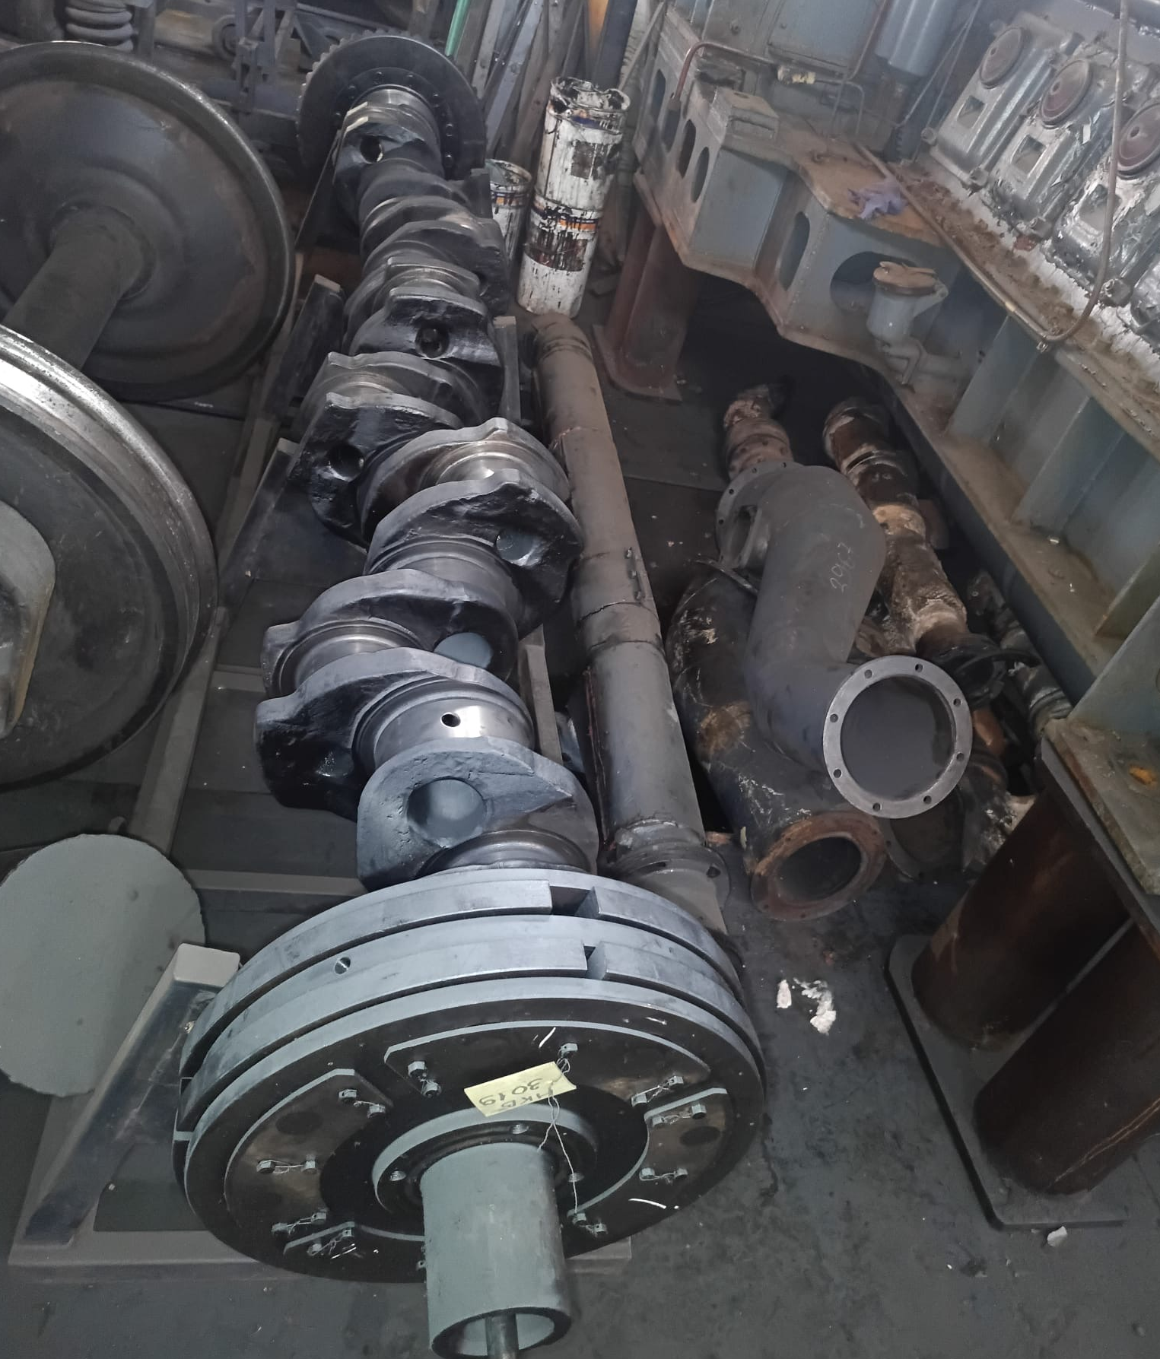

  - Location of Spare Parts: 2.Preču Street 30, Daugavpils.
  - The auction participant has the right to inspect the Spare Parts at their location, subject to prior agreement with the Seller’s contact person referred to in clause 10.1.1 of the Terms and Conditions regarding the date and time of the inspection.
  - The Spare Parts must be collected from their location within 30 (thirty) calendar days of the signing of the purchase contract. Collection shall take place in accordance with a mutually agreed collection schedule; if necessary, an extension of the collection deadline may be agreed.
  - The Seller shall hand over and the Buyer shall accept the Spare Parts at the address specified in clause 2.3. The handover and acceptance of Spare Parts may be carried out in batches.
  - The dates and times for the handover of the Spare Parts shall be agreed separately between the Buyer and the Seller through the exchange of written information via email. The agreed dates and times for the handover and acceptance of the Spare Parts shall be binding on both the Seller and the Buyer.
  - All costs associated with loading the Spare Parts onto a vehicle and transporting them from the handover point shall be borne by the Buyer.

- Starting price and bidding increment
  - The Spare Parts are sold in 15 (fifteen) lots.
  - Starting price and bidding increment:
Lot No. | Name of spare part | Year(s) of manufacture | Quantity | Starting price, EUR | Bid increment, EUR
1. | TEP70 locomotive bogie frame | 1989 | 1 | 1,000 | 10
2. | TEP70 locomotive bogie frame | 1989 | 1 | 1,000 | 10
3. | ЭД-121А У1 traction electric motor | 1989 | 1 | 4,000 | 10
4. | ЭД-121А У1 traction electric motor | 1991 | 1 | 4,000 | 10
5. | ЭД-121А У1 traction electric motor | 1994 | 1 | 4,000 | 10
6. | ЭД-121А У1 traction electric motor (disassembled) | 1989 | 1 | 500 | 1
7. | ЭД-121А У1 traction electric motor (disassembled) | 1990 | 1 | 500 | 1
8. | ЭД-121А У1 traction electric motor (disassembled) | 1993 | 1 | 500 | 1
9. | TEP70 locomotive wheel set | 1989 | 15 | 15,000 | 100
10. | 10Д100М diesel engine block | 1980 | 1 | 15,000 | 100
11. | 2А-9ДГ diesel generator set | 1985 | 1 | 25,000 | 100
12 | 2А-5Д49 diesel engine block | 1985 | 1 | 10,000 | 100
13. | 10Д100 diesel engine crankshaft upper | 1985 | 1 | 10,000 | 100
14. | 10Д100 diesel engine crankshaft upper | 1985 | 1 | 10,000 | 100
15 | Lower crankshaft of the 10Д100 diesel engine | 1985 | 1 | 13,000 | 100
  - A participant may submit a bid for one or more auction lots.
  - Value added tax is applied to the purchase price in accordance with the procedure and at the rate specified in the Value Added Tax Act.
  - The seller shall refund the value added tax paid by the buyer (non-resident) within 5 (five) working days of the date on which the seller has been provided with documents (CMR international consignment note, export customs declaration) confirming the export of the Spare Parts from the territory of the Republic of Latvia and/or the European Union.

- Announcement of the auction
  - The seller publishes information about the auction in the official gazette *Latvijas Vēstnesis*, on the website http://ldzcargo.ldz.lv and on the electronic auction site http://auctioncargo.ldz.lv.

- Auction deposit
  - To participate in the auction, a security deposit of 10 % (ten percent) of the starting price of the relevant lot is required for each lot on which the participant intends to bid (hereinafter – the security deposit). The deposit paid by the successful bidder will be refunded upon full payment of the purchase price for the reserve parts. For the other auction participants, the security deposit shall be refunded within 10 (ten) working days of the confirmation of the auction results, provided that none of the circumstances referred to in clause 5.3 of these Regulations have arisen.
  - The security deposit must be paid into and received in the Seller’s current account No. LV08RIKO0000082999854 by the date specified in clause 6.5 of these Terms and Conditions, Luminor Bank AS Latvian Branch, SWIFT code RIKOLV2X, with the payment reference stated as: “Security deposit for the auction of spare parts, lot No. __.”
  - The security deposit shall not be refunded:

    - to any participant registered for the auction if, during the auction, none of the participants or the sole participant bids even the starting price;
    - to the successful bidder, if they refuse to enter into a purchase contract.

- Auction participants
  - An Auction participant may be a legal entity registered within the EU or outside the EU (excluding the Russian Federation and the Republic of Belarus).
  - The Commission Secretary shall not authorise as a participant in the Auction any person to whom any of the following conditions apply:
    - insolvency proceedings have been initiated against the auction participant, its economic activity has been suspended or terminated, or it is being wound up;
    - the Auction Participant or persons associated with it (including the owner, beneficial owner, member of the board of directors or supervisory board, or authorised representative) are subject to international or national sanctions, or to sanctions imposed by a Member State of the European Union or the North Atlantic Treaty Organisation that significantly affect financial and capital market interests.
  - The Commission Secretary shall have the right to refuse authorisation to participate in the Auction to any participant to whom any of the following conditions apply:
    - the participant has tax arrears (including arrears in compulsory state social insurance contributions) in Latvia or in the country where the Auction participant is registered or where they have their permanent residence, the total amount of which in any one country exceeds 150 euros;
    - the Auction Participant has outstanding debts to the Seller on the date of registration for the Auction;
    - if the Auction participant has, within the previous 6 (six) months, taken part in an auction organised by the Seller, has been declared the winner of that auction or has acquired the right to conclude a purchase contract, but has, without good cause, refused to enter into the purchase contract or has failed to do so within the time limit specified in the relevant auction terms and conditions, or the Seller has unilaterally withdrawn from the concluded purchase contract due to the buyer’s failure to fulfil or improper fulfilment of their obligations;
    - if there are other valid obstacles to the authorisation of the auction participant for the Auction.
  - To become a participant in the auction, a person must create an EAW account (instructions on how to use EAW can be found on the website: https://auctioncargo.ldz.lv/ under ‘User Guidelines’), pay a security deposit and email the documents specified in Clause 6.5 of the Regulations to the Commission Secretary (Clause 10.1.2 of the Regulations). Once the documents have been verified, the Commission Secretary will authorise the Auction participant, who will then be able to register for the Auction.
  - Persons wishing to be authorised to participate in the Auction must send the following documents to the Commission Secretary by email by 12.00 on 28 October 2026:
    - For legal entities registered in the Republic of Latvia:
      - an application to participate in the auction in accordance with Annex 2 to the Regulations (signed with a secure electronic signature);
      - a power of attorney (signed with a secure electronic signature) to represent the legal person in the Auction, if the legal person is not represented by a member of the legal person’s executive body with separate powers of representation, as indicated in the public database of the Commercial Register of the Republic of Latvia.
      - An identification form for legal entities, completed by the cooperation partner in accordance with Annex 3 to the Regulations (signed with a secure electronic signature).
      - A document confirming payment of the auction deposit.
    - For legal entities registered in another country:
      - an application to participate in the auction in accordance with Annex 2 to the Regulations (signed in PDF format with a secure electronic signature, specifying the website for verifying the authenticity of the signature);
      - a copy of the certificate of registration;
      - articles of association and/or a decision by the founder(s) (members/shareholders) on the appointment of members of the legal entity’s executive body with separate powers of representation;
      - a certificate issued by a competent authority in the country where the enderer is registered, confirming that the tenderer has no tax arrears (including arrears in compulsory social security contributions) in that country totalling more than 150 euros;
      - a document (or other evidence) issued by a competent authority confirming the rights of representation and their scope, if the relevant country’s legislation does not provide for the public registration of such information. If the auction participant is represented by a person not mentioned in the aforementioned document, a power of attorney must also be attached (signed in PDF format with a secure electronic signature, specifying the website for verifying the authenticity of the signature);
      - An identification form for legal entities, completed by the cooperation partner in accordance with Annex 3 to the Regulations (signed in PDF format with a secure electronic signature, specifying the website where the authenticity of the signature can be verified).
      - A document confirming payment of the auction security deposit.
  - The documents referred to in clauses 6.5.2.1 to 6.5.2.6 of the Regulations must be accompanied by a translation into Latvian or English.
  - The Commission Secretary has the right to refuse to authorise a bidder to participate in the Auction if any of the documents referred to in clause 6.5 of the Regulations have not been submitted and/or if the submitted document does not comply with the requirements of clauses 6.5–6.6 of the Regulations.
  - Following examination of the documents submitted by the applicants, the Commission Secretary shall, using the EAW, authorise the Auction participant or notify them of the refusal of authorisation. Information regarding the outcome of the authorisation shall be sent to the applicant’s email address specified in the EAW.
  - Following the conclusion of the Auction, the Commission Secretary revokes the authorisation status of all Auction participants.

- Conduct of the auction
  - The bidding period for the auction is 1 (one) hour from the start date and time of the auction, as specified in clause 1.5 of the Regulations.
  - The bidding time in the EAW is automatically extended by 15 (fifteen) minutes from the time of the last bid if bidders continue to submit bids 15 (fifteen) minutes before the end of the Auction, until the last bidder places their bid.
  - After the auction has ended, the EAW displays the bidding time and the highest bid price. This information remains available on the EAW for a further 30 (thirty) days after the auction closes. The Auction period shall be extended until 13.00 on the next working day if, due to a malfunction of the EAW, bidding was not possible during the last 10 (ten) minutes before the close of the Auction.
  - Upon the conclusion of the Auction, the Commission’s secretary shall draw up a report on the Auction results, attaching the data received from the EAW regarding the Auction increments and bidders. The report shall be approved by the Commission.
  - If the bidder who submitted the highest bid (hereinafter – the Highest Bidder) refuses to enter into a purchase contract, the Seller may invite the Auction participant who was outbid by the Highest Bidder to purchase the Reserve Lots.
  - The auction shall be deemed to have failed if:
    - no participant has registered for the auction;
    - no registered participant bids the starting price of the auction;
    - information is received regarding significant legal or technical defects in the auction item which were not known prior to the start of the auction and which could affect potential participants’ ability to make an informed decision regarding participation in the auction;
    - the Seller’s board of directors does not approve the results of the Auction;
    - during the course of the auction or within 24 (twenty-four) hours of the auction’s conclusion, a notification is received regarding significant disruptions to the EAW that may affect the auction results, or regarding breaches of the EAW’s security system.

- Submission of complaints, approval of the auction results and conclusion of the contract
  - Auction participants are entitled to submit a written complaint to the Commission regarding the conduct of the Auction. The Commission shall provide a written response within 3 (three) working days of the date of receipt of the complaint.
  - If necessary, the Commission shall submit the auction minutes to the Seller’s board for approval within 10 (ten) working days of the conclusion of the auction.
  - If the results of the auction have been submitted to the Seller’s board for approval, the Successful Bidder and the auction participant specified in clause 7.5 of the Terms and Conditions shall only acquire the right to purchase the Reserve Shares once these results have been approved.
  - The Seller shall inform the Successful Bidder of the decision taken, send them a draft contract and invite them to conclude the contract for the purchase of the Reserve Shares within 5 (five) working days.
  - If the purchase contract has not been signed within 5 (five) working days of the date on which the draft contract was sent, the Seller shall be entitled to consider that the Successful Bidder has declined to purchase the Reserve Parts.
  - In the circumstances referred to in Clause 8.5 of the Regulations, the Commission shall be entitled to invite the next highest bidder to conclude a purchase contract for the Spare Parts at the price offered by them at the Auction. Should this Auction participant agree, the Commission shall draw up a report setting out the aforementioned circumstances and confirming this in accordance with the Seller’s internal regulations.

- Procedure for payment of the purchase price and other charges
  - Upon signing the purchase contract, the Buyer shall pay the full purchase price for the Spare Parts in accordance with the terms of the purchase contract.
  - The Auction Deposit paid by the Buyer shall remain in the Seller’s possession until the full purchase price for the Reserve Shares has been paid.

- The Seller’s contact persons
  - The Seller’s contact persons:
    - for technical enquiries – Aleksejs Ivčenko, telephone (+371) 29531773, email: aleksejs.ivcenko@ldz.lv ;
    - Secretary to the Commission – Inese Stendzeniece, telephone: +371 25719192, email: iepirkumi.cargo@ldz.lv

Enclosed:
Annex 1 – “Draft Purchase Contract”;
Annex 2 – “Application by a legal entity to participate in the auction (form)”;
Annex 3 – “Cooperation partner identification and questionnaire form for legal entities”.

Annex 1
to the regulations of the electronic auction (Id. No. REAL 2026/23)
for the sale of locomotive spare parts

DRAFT (The purchase contract with the successful bidder shall be concluded in accordance with this draft. The terms of the purchase contract may be mutually clarified prior to its signing, provided that such clarifications relate to the formalisation of the auction results and are of a minor nature)

Riga, __________ 2026
or the date of the contract is the date of the most recent secure electronic signature and time stamp attached

CONTRACT No. ___________

The limited liability company “LDZ CARGO”, registration No. 40003788421 (hereinafter – the Seller), represented by on the basis of power of attorney No. _____ dated ______, on the one hand, and
_________________________________, registration No. _____ (hereinafter referred to as the “Buyer”), represented by ______________, acting on the basis of _____________, on the other hand, both together referred to as the “Parties”, hereby enter into the following contract of sale (hereinafter referred to as the “Contract”):

- Subject matter of the Contract
  - In accordance with the terms set out in this Contract, the Seller shall sell and transfer to the Buyer, whilst the Buyer purchases and accepts from the Seller _____________, hereinafter referred to as the Goods, at the price determined at the auction organised by the Seller on _______ 2026 ____________ (held on the electronic auction website http://auctioncargo.ldz.lv).
  - Information regarding the Goods is set out in Annex 1 to this Contract, ‘Technical Specification of the Goods’, which forms an integral part of this Contract.
  - The Parties confirm that they are aware that:
    - the Assets to be disposed of under this Contract are second-hand locomotive spare parts, which are being sold at auction in the technical and visual condition in which they are found on the day of the auction;
    - the Goods may contain hidden or visible defects, natural wear and tear, and damage resulting from previous use.
  - The Buyer is expressly informed, acknowledges and agrees that the Goods are sold as incomplete sets. Any omissions in the set and missing components are specified in the auction documentation and shall not constitute grounds for making a claim against the Seller.
  - The Parties confirm that they are aware of the value of the Goods and waive any mutual claims for the cancellation of the Contract or the amendment of the purchase price on the grounds of excessive loss.

- Handover and acceptance of the Goods; special conditions
  - The Seller delivers and the Buyer accepts the Goods without any commercial or statutory warranties (sold ‘as is’). The Seller accepts no liability whatsoever for the future functionality, service life or suitability of the Goods for the Buyer’s business purposes, and the Buyer undertakes not to make any claims against the Seller in this regard.
  - The handover of the Goods shall take place at the location of the Goods – 2.Preču Street 30, Daugavpils.
  - The handover of the Goods may be carried out in batches.
  - The Buyer must take delivery of the Goods from the Seller no later than 30 (thirty) calendar days after the date on which the Contract is signed by both parties. Removal shall take place in accordance with a mutually agreed removal schedule.
  - The Buyer shall arrange for the loading and removal of the goods.
  - The Buyer and the Seller shall agree separately on the date and time of acceptance and handover of the Goods by exchanging written information via email. The agreed dates and times for the handover and acceptance of the Goods shall be binding on both the Seller and the Buyer.
  - Upon full payment of the Purchase Price, the Seller shall hand over the Goods to the Buyer by means of a handover certificate, which shall be signed:
    - on behalf of the Seller __________________________;
    - on behalf of the Buyer _____________________________.
  - From the moment the handover certificate is signed, the Buyer assumes all risks of damage to or loss of the Goods due to unforeseeable circumstances.

- Purchase price and payment terms
  - The purchase price for the Goods is __________ EUR (____________ euros, 00 cents), to which value added tax at 21% (twenty-one percent) is added in accordance with the requirements of the Value Added Tax Act in force in the Republic of Latvia (VAT) ____________ EUR (______________ euros, 00 cents), totalling _____________ EUR (____________ euros and 00 cents) (hereinafter – the Purchase Price).
  - The Buyer has paid the Seller an auction deposit of _____ EUR, which shall remain at the Seller’s disposal until the Purchase Price has been paid in full.
  - The Buyer undertakes to pay the Purchase Price, on the basis of an invoice issued by the Seller, no later than 10 (ten) calendar days after the date of mutual signing of the Contract and the date of issue of the invoice, by transferring the amount to the Seller’s account – limited liability company “LDZ CARGO”, registration number 40003788421, Luminor Bank AS Latvian branch, account no. LV08RIKO0000082999854. The date on which the Purchase Price specified in the invoice is credited to the Seller’s account shall be deemed the date of payment of the Purchase Price. The Seller shall send the invoice to the Buyer from the email address: cargo.rekini@ldz.lv to the Buyer’s email address: ________________. Invoices are issued electronically and are valid without a signature.
  - If the Purchase Price is not paid in the amount and/or by the deadline specified in this Contract, the Buyer shall pay the Seller default interest at a rate of 0.1% (zero point one per cent) of the outstanding amount for each day of delay.
  - Payment of late payment interest shall not release the Buyer from the obligation to compensate for losses and to perform the Contract.
  - Interest on late payment and other payments provided for in the Contract shall be made on the basis of issued invoices within 10 (ten) calendar days of the invoice being issued.
  - Any payments arising from this Contract shall be set off in accordance with Article 1843 of the Civil Law, i.e. payments shall first be set off against any outstanding interest, then against the principal debt, and only thereafter against the contractual penalty.
  - (Where applicable) The Seller shall refund the value-added tax paid by the Buyer (a non-resident) within 5 (five) working days of the Seller being provided with the documents (CMR international consignment note, export customs declaration) confirming the export of the Goods from the Republic of Latvia and/or the territory of the European Union.

- Certifications and liability
  - The Buyer confirms that, prior to participating in the auction and signing this Contract, they were given a full opportunity to carry out a visual and technical inspection of the Goods, to check that they are complete and to assess their condition.
  - By signing this Contract, the Buyer confirms that it has no claims regarding the quality, composition, contents or technical condition of the Goods, and the Buyer voluntarily assumes all risks associated with the future use, repair or disposal of the Goods.
  - The Buyer guarantees that it will fulfil the obligations set out in the Contract, including payment of the Purchase Price within the timeframe, in the amount and in the manner agreed in the Contract.
  - Title to the Goods and all risks of accidental damage to or loss of the Goods shall pass to the Buyer upon the mutual signing of the handover certificate.
  - The Buyer undertakes to comply, on the Seller’s premises (Clause 2.2 of the Contract), with health and safety, occupational health and safety and fire safety regulations, the requirements of other statutory provisions, and the Seller’s instructions.
  - The Buyer represents and warrants that:
    - it complies with international and national sanctions, as well as sanctions and related restrictions imposed by a Member State of the European Union or the North Atlantic Treaty Organisation that significantly affect the interests of the financial and capital markets;
    - will not engage in, will terminate and will not maintain any business relations with persons who breach the legal provisions, sanctions and restrictions specified in Clause 4.6.1 of the Contract;
    - upon the first written request from the Seller, within the specified timeframe and in the specified format, to submit information and documents relating to the Buyer’s economic and professional activities in order to confirm compliance with the sanctions.
  - The Buyer acknowledges and confirms that, in the event of a breach of the provisions of Clause 4.6 of the Contract:
    - the Seller shall be entitled not to fulfil the obligations assumed under the Contract, as well as to terminate the Contract and all other legal relationships with the Buyer immediately and unilaterally, and to take any other actions provided for in legislation and in other existing contractual relationships with the Buyer;
    - The Buyer shall be fully liable and undertakes to compensate the Seller for all losses incurred as a result of such breaches attributable to the Buyer.

- Settlement of Disputes
  - All disputes and disagreements that may arise from or in connection with the Contract shall be resolved by the Parties through mutual negotiation.
  - Each Party shall be entitled to submit a claim in writing to the other Party in accordance with the procedure set out in Clause 11.4 of the Contract. The claim must be well-founded and supported by documentary evidence. The Parties agree that claims shall be considered within no more than 10 (ten) days of receipt.
  - If, within 1 (one) month of the dispute arising, the Parties are unable to reach an agreement on the resolution of the dispute through negotiation, the dispute shall be resolved in a court of the Republic of Latvia in accordance with the laws of the Republic of Latvia.

- Term and termination of the Contract
  - The Contract shall enter into force on the date of its signing by both Parties and shall remain in force until 31 January 2026. With regard to the Parties’ unfulfilled obligations, claims for compensation for losses and the payment of contractual penalties, the Contract shall remain in force until such time as the Parties have fully and properly fulfilled their obligations arising from the Contract. The Parties shall have the right to agree in writing to extend the term of the Contract where there is a valid reason for doing so (agreement between the Parties to extend the deadline for the removal of the Goods, other valid reasons).
  - The Contract may be terminated by mutual written agreement between the Parties.
  - The Seller is entitled to terminate the Contract unilaterally in any of the following circumstances:
    - if insolvency proceedings have been initiated against the Buyer, its business operations have been suspended or terminated, liquidation proceedings have been initiated against the Buyer, or the Buyer’s business operations have been suspended in accordance ^{with Section} 34^{(1) of}the Law ‘On Taxes and Duties’;
    - if it is not possible to perform the Contract because the Buyer is subject to international or national sanctions, or to sanctions imposed by a Member State of the European Union or the North Atlantic Treaty Organisation that significantly affect financial and capital market interests;
    - the Buyer has failed to pay the Purchase Price or any part thereof within the time limit and in the amount specified in the Contract, and such delay exceeds 5 (five) working days.
  - If the Contract is terminated in accordance with Clauses 6.3.1 and/or 6.3.2 of the Contract, the Seller shall send the Buyer written notice thereof in accordance with the procedure set out in Clause 11.4 of the Contract, and the Contract shall be terminated with immediate effect.

- Confidentiality
  - The provisions of the Contract, as well as any information relating to the parties’ cooperation or which has come into the parties’ possession as a result of the performance of the Contract, shall be deemed to be the parties’ trade secrets and shall not be disclosed to third parties during the term of the Contract or thereafter without the prior written consent of the other party. This obligation shall not apply to information that is publicly available or to information that must be disclosed to the relevant state authorities in accordance with the applicable legislation, provided that such information is supplied to those authorities.
  - The other party undertakes to use any information received from one party that contains trade secrets solely for the purpose specified in clause 1.1 of the contract, whilst respecting the commercial interests of the parties and this confidentiality obligation.
  - The Buyer shall not, without the Seller’s prior consent, process information received from the Seller in the course of the performance of the Contract using artificial intelligence or machine learning tools, through which the Seller’s information is transferred, stored, processed or made available outside the environment controlled by the Seller. Such conduct shall be deemed an unauthorised disclosure of information to third parties and a breach of the Contract.

- Protection of personal data
  - The Parties confirm that they are aware that personal data provided by one Party, where necessary for the performance of the contract, may be processed only in accordance with the subject matter of the contract, to the extent specified in the contract, for the duration of the contract and only in accordance with the requirements of applicable legislation.
  - The Parties shall ensure that the employees designated as contact persons in this contract are informed of the right to disclose their contact details within the framework of their employment relationship and for the purpose of performing their duties, as well as of the employees’ rights as data subjects in accordance with the applicable laws and regulations governing the protection of personal data.
  - The Parties undertake to ensure a level of protection for the personal data provided by the other Party that complies with the applicable legislation.
  - The Parties undertake not to disclose to third parties any personal data provided by the other Party. If, in accordance with applicable legislation, the Parties may be subject to such an obligation, they shall inform the other Party thereof prior to the disclosure of personal data, unless prohibited by applicable legislation.
  - Each Party shall be independently liable to the Data Subject for any failure to comply with the rules on the protection and processing of personal data and, if a Party’s liability is established, that party must satisfy the Data Subject’s claims relating to the personal data breach and its rectification, as well as pay any administrative fines relating to the personal data breach and compensate for any damages awarded by a court judgement.
  - The parties undertake to destroy the personal data submitted by the other party as soon as the need to process it ceases.
- Business ethics
  - By signing this contract, the Purchaser confirms that they have familiarised themselves with the ‘Latvijas dzelzceļš’ Group’s fundamental principles of business ethics for cooperation partners (hereinafter referred to as the ‘Fundamental Principles’), published on the ‘Latvijas dzelzceļš’ Group’s website at www.ldz.lv, complies with them and undertakes to continue to strictly observe them themselves and to ensure that their employees and any subcontractors involved in the performance of the contract also comply with them.
  - The Buyer is obliged to inform the Seller immediately if a situation is identified in which any of the Fundamental Principles have been breached, and to inform the Seller of the measures being taken to resolve the situation and prevent its recurrence in the future. Should such information not be provided, but the Seller becomes aware that the Buyer has breached any of the Core Principles, the continuation of the cooperation will be assessed in accordance with the procedure and to the extent provided for by the laws of the Republic of Latvia.
  - If, in the course of the performance of the contract, the Buyer comes into possession of information or has reasonable grounds to suspect that an employee of the Seller’s company, either personally or through an intermediary, is demanding, accepting or offering benefits of any kind, whether of a material benefits of a financial or other nature to any persons with the intention of securing the adoption of a specific unlawful decision, obtaining unlawful benefits or advantages, or achieving any other self-serving objective in the interests of the individual, the Seller or any other person, The Buyer is obliged to immediately inform the Security Directorate of the parent company of the “Latvijas dzelzceļš” Group, using the reporting options available on the Group’s website at www.ldz.lv. The report must include information, facts or materials that credibly indicate the aforementioned activities or provide reasonable grounds for suspicion of such activities. “Latvian Railways” guarantees that the information will be assessed comprehensively and objectively, and that no unjustified negative consequences or actions will be directed against the whistleblower, the company they represent, or any of its other employees.

- Force majeure
  - In the event that either Party is unable, in whole or in part, to fulfil its obligations under this Contract due to the following circumstances – fire, natural disaster, war, blockades, export or import bans and similar circumstances, the Parties shall extend the deadlines for the performance of the obligations under this Contract accordingly for the duration of such circumstances.
  - The Party for whom the performance of the obligations under this Contract has become impossible must, no later than 5 (five) working days from the occurrence of the relevant circumstances, notify the other Party in writing of the commencement of the aforementioned circumstances, providing relevant evidence, and their cessation.
  - If, due to force majeure, performance of the Contract is impossible for a period exceeding 30 (thirty) days, each Party shall be entitled to unilaterally terminate the Contract by notifying the other Party in writing. If the Contract is terminated unilaterally in this manner, neither Party shall be entitled to claim compensation for losses from the other.

- Other provisions
  - Any amendments and additions to this Contract shall be made in writing and, upon being signed by both Parties, shall be attached to this Contract as an integral part thereof.
  - The Buyer shall not be entitled to assign, in whole or in part, the rights and obligations set out in this Contract to third parties without the Seller’s written consent.
  - The Parties shall immediately notify each other in writing of any changes to their details by means of a letter signed by a person authorised to represent the relevant Party (an authorised signatory) within the company.
  - The Parties agree that any notice, request or other information and communication to be provided, requested or permitted under this Contract shall be in writing and shall be deemed to have been served if:
    - are delivered in person or by a courier or delivery service provider – on the date of actual delivery, as confirmed by the other Party’s acknowledgement of receipt;
    - are sent by registered post to the other party’s registered address – on the seventh day following the date indicated on the post office’s stamp confirming acceptance of the registered post for dispatch;
    - sent to the other party’s email address specified in the contract details – on the second working day.
  - In the cases referred to in Clause 11.4 of the contract, if documents are submitted in accordance with the above on a day that is not a working day or after normal working hours, they shall be deemed to have been received on the next working day. For the purposes of this Contract, a working day is any day from Monday to Friday, except where the day in question is a public holiday or a bank holiday in accordance with the laws and regulations of the Republic of Latvia.
  - The reorganisation of the Parties or a change in their management shall not constitute grounds for the suspension or termination of the Contract. In any event, and in the event that either Party is reorganised or wound up, the Contract shall remain in force and its provisions shall be binding on the Party’s successor in title.
  - Any matters not covered by this Contract shall be resolved by the Parties in accordance with the legislation in force in the Republic of Latvia.
  - The Contract has been drawn up in the Latvian language in the form of an electronic document, together with Annex 1, and has been signed with a secure electronic signature containing a time stamp. The date of signing of the Contract shall be the date of the last secure electronic signature appended thereto and its time stamp.
  - As at the date of signing, the Contract comprises Annex 1 – ‘Technical Specification of the Goods’ on _lp.

8. Details and signatures of the Parties

Seller:  Limited Liability Company  “LDZ CARGO”  Registration No. 40003788421  VAT registration No. LV40003788421  Registered address: Dzirnavu iela 147 k-1, Riga, LV-1050, Latvia  Bank details:  Luminor Bank AS, Latvian branch  Account No. LV08RIKO0000082999854  SWIFT code: RIKOLV2X  Contact details:  Telephone: ____________  Email: _______________  /……/ __________________  /….../ _________________ | Buyer:  Name  Registration No./personal identification number  VAT registration No.  Registered address / declared address  Bank details:  Bank name__________  Account No. ___________________  SWIFT code: ___________  Contact details:  Telephone: ____________  Email: _______________  /……./________________________
The contract has been signed with a secure electronic signature and includes a time stamp

Annex 2

to the terms and conditions of the electronic auction (Ref. No. REAL 2026/23)

for the sale of locomotive spare parts

Place, ___.___.2026.
No. ________

APPLICATION BY A LEGAL ENTITY TO PARTICIPATE IN THE AUCTION
“Electronic auction (Ref. No. REAL 2026/23)

for the sale of locomotive spare parts”

Tenderer:
Name
Registration number
Country of registration
Registered address
Bank details and current account information
Telephone number:
Email address (for communication and receiving correspondence):
Basis of representation of the Tenderer’s official or authorised representative who will represent the Tenderer at the auction (power of attorney, articles of association, other document)
Name, surname and position of the bidder’s official or authorised representative; name, surname, position and basis of representation (power of attorney, articles of association, other document) of the person who will sign the contract
By submitting this application, the bidder confirms its participation in:
Limited Liability Company “LDZ CARGO”, registration No. 40003788421, registered office: Dzirnavu iela 147 k-1, Riga, LV-1050 (hereinafter – SIA “LDZ CARGO”) for the sale of locomotive spare parts (hereinafter – the Auction).
Method of participation: online via the electronic auction website http://auctioncargo.ldz.lv (hereinafter – EAW).
The bidder confirms that:
      - has familiarised themselves with the Auction Regulations and their annexes and agrees to all the requirements set out in the Auction Regulations and their annexes;
      - has familiarised themselves with the Terms of Use of the EAW;
      - undertakes to fulfil the terms of the purchase contract attached as Annex 2 to the Auction Regulations, should the Bidder be declared the winner of the Auction in accordance with the procedure set out in the Auction Regulations;
      - The Bidder has not been found guilty by a court of law of participation in a criminal organisation, corruption, financial fraud or the laundering of criminally obtained funds, and no breaches of professional conduct have been established in accordance with the law during the last three years up to the date of submission of the application, nor have they been declared insolvent, are not in the process of liquidation, their business operations have not been suspended or terminated, and they have no outstanding debts in respect of taxes or compulsory state social insurance contributions;
      - The Tenderer is not subject to any international or national sanctions, nor to any sanctions or restrictions imposed by a Member State of the European Union or the North Atlantic Treaty Organisation that significantly affect financial and capital market interests; this includes members of the Tenderer’s management board, supervisory board, beneficial owners, authorised representatives and procurators;
      - The Tenderer undertakes to inform SIA “LDZ CARGO” in writing without delay in the event that the Tenderer, a member of the Bidder’s board of directors or supervisory board, a beneficial owner, an authorised representative or a procurator, the sanctions referred to in the preceding paragraph of this declaration, as well as any other international or national sanctions;
      - On the date of submission of this application, the Bidder has no outstanding debts to SIA “LDZ CARGO”;
      - the documents referred to in clause 6.5 of the Auction Regulations have been attached to this application;
      - agrees that LLC “LDZ CARGO” may use the following contact details to communicate with the Bidder regarding the progress of the Auction: __________________________ (email address, telephone number).

Date
Name, surname and position of the Bidder’s official or authorised representative
Signature

Annex 3
to the regulations of the electronic auction (Id. No. REAL 2026/23)
for the sale of locomotive spare parts

Partner identification and questionnaire form for legal entities

In accordance with the objectives of the Law on the Prevention of Money Laundering and the Financing of Terrorism and Proliferation, and the transaction monitoring requirements for entities subject to that law (including credit institutions of the Republic of Latvia), in order to prevent potential risks associated with money laundering and the financing of terrorism and proliferation, LLC “LDZ CARGO” requests that you provide the necessary information by completing this form:
- Name of the legal entity (including partners in a partnership):

- Registration number/equivalent identifier:

- Country of registration:

- Authorised representatives:
First name, surname and personal identification number of the authorised representative; if the person does not have a personal identification number, then an equivalent identifier, such as date of birth (day, month, year), and nationality (country of citizenship)¹ .

- Board:
First name, surname and personal identification number of the chairperson of the board or a board member; if the person does not have a personal identification number, then an equivalent identifier, such as date of birth, month, year, and nationality (country of citizenship)¹ .

- Council (if established):
First name, surname, personal identification number of the Chair of the Council/Council member; if the person does not have a personal identification number, then an equivalent identifier, such as date of birth, month, year, nationality (country of origin)¹ .

- Beneficial owner(s) (BO) :
Within the meaning of the Law on the Prevention of Money Laundering and the Financing of Terrorism and Proliferation, a beneficial owner is a natural person who is the owner of a legal person, or who controls a client, or on whose behalf, for whose benefit or in whose interests a business relationship is established or a transaction is carried out, and who is at least:
(a) a natural person who, through direct or indirect participation, holds more than 25 per cent of the client’s company’s share capital or total number of voting shares;
b) a natural person who, directly or indirectly, controls the company’s operations; First name, surname, personal identification number (if the person does not have a personal identification number, then an equivalent identifier, such as date of birth, month, year), nationality (country of citizenship)1, PLG directly or indirectly holds more than 25 per cent of the shares/voting shares out of the total number of shares of the legal entity.

I/we confirm that, having used all possible means of verification, it has been concluded that it is not possible to identify any natural person - who is a PLG within the meaning of Article 1(5) of the Law on the Prevention of Money Laundering and the Financing of Terrorism and Proliferation, and that any doubts as to whether the legal entity has a PLG have been ruled out.
It is not possible to identify the beneficial owner because the cooperation partner is:
a subsidiary public body;
a direct administration body or an indirect administration body;
a capital company controlled by the State or a local authority;
a commercial entity whose shares are listed on a regulated market.

8. What is the nature of the company’s business? Please provide a description of the company (website address, location of the company’s branches and production facilities, if any) _______________________________________________________________________
9. Has there been a change in shareholders or members in your company over the last three years?
Yes (please specify) ________________________________________________________
No
10. By signing this identification and questionnaire form, we confirm that should the information provided in this form change, we will notify SIA “LDZ CARGO” immediately by sending the updated information to its registered address or by email tocargo@ldz.lv .

Legal representative: | Status (board member, authorised signatory, authorised representative, other)
Legal representative: | First name, surname
Legal representative: | Signature³
Legal representative: | Date

¹ The ‘Latvijas dzelzceļš’ Group processes the personal data referred to in this clause in accordance with Regulation (EU) 2016/679 of the European Parliament and of the Council of 27 April 2016 on the protection of natural persons with regard to the processing of personal data and on the free movement of such data (hereinafter referred to as the GDPR):
1/ on the basis of Article 6(1)(b) of the GDPR – for the purpose of entering into a contractual relationship and ensuring the performance of the contract at the request of the data subject (contracting party), and
2/ On the basis of Article 6(1)(c) of the GDPR, in order to comply with the legal obligation incumbent on the controller (LDZ) to verify its business partners, in accordance with the requirements of the International and National Sanctions Act of the Republic of Latvia and the Law on the Prevention of Money Laundering and the Financing of Terrorism and Proliferation;
3/ On the basis of Article 6(1)(e) of the GDPR, in order to carry out a task carried out in the public interest – the prevention of terrorism and the mitigation of the risk of fraud.
² Within the meaning of Article 1(5) of the ‘Law on the Prevention of Money Laundering and the Financing of Terrorism and Proliferation’.
³ or an electronic signature

